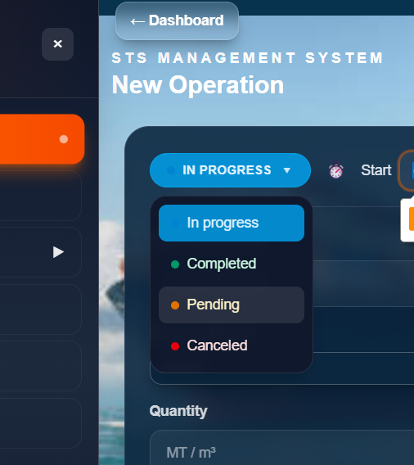
STS Documentation
Change the pending to Lined up

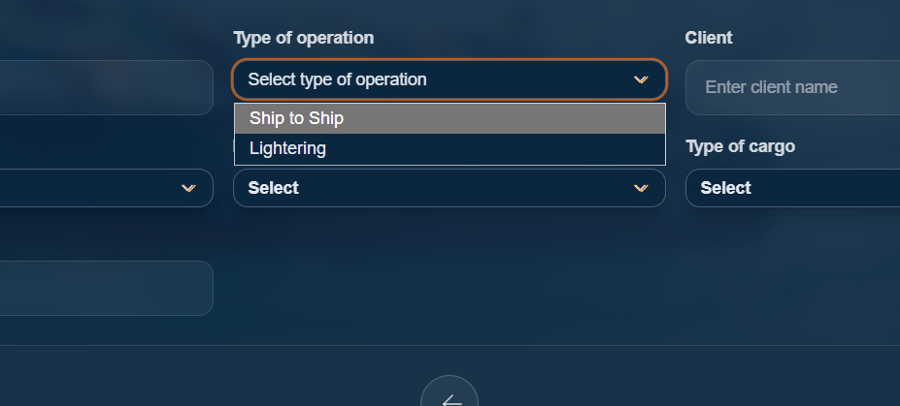
Type of operation -> drop down
- Ship to Ship
- POAC
- Fender Hire
- Hose hire
- STS Equipment Hire
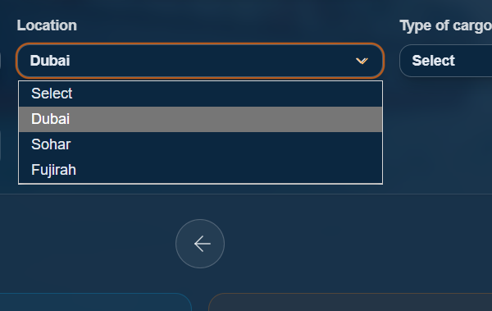
Provided locations are not present in drop down
Dubai
Fujairah
Sohar
Khorfakkan
Salalah
Duqm
Muscat
Ajman
Tanjung bruas
Brunei
Mombasa
Yeosu

Given Cargo types are also not present in the drop down – which is previously given in word sheet

Metric tons to barrels conversion .

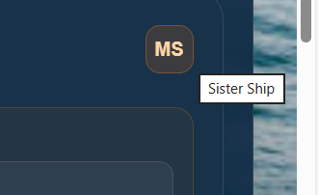
MS is Daughter ship

Why word (main) ?

Some brainstorming required with uploading of documents in STS Documentation .
- Since those documents are now sharable form , but the sections now have the upload functionality , Please advise if the form will be automatically sit in the path.

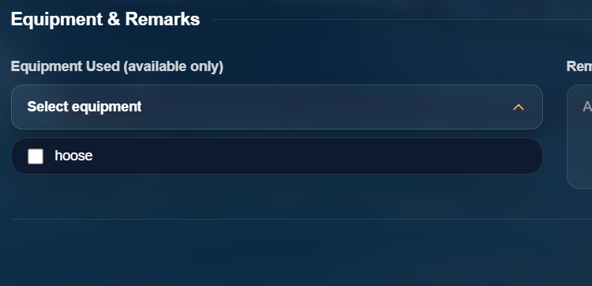
Equipments database needs to be fed inside the procurement dept , to access this equipment selection.

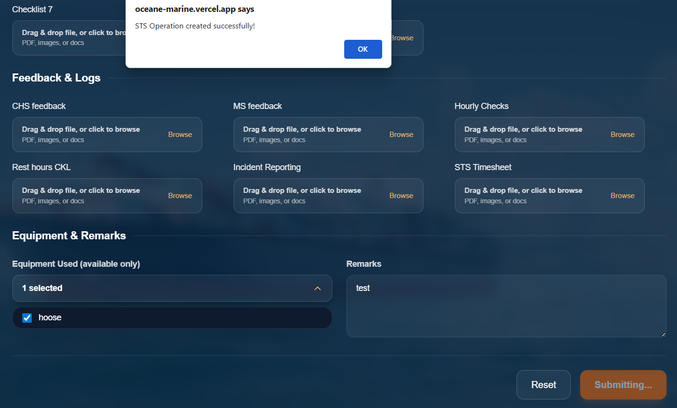
Instead of the pop up of successfully created just give a landing page with big green tick on the center says new operation created .
And after submitting a form , the next it automatically open a blank , but there is no option to view the previous forms ,
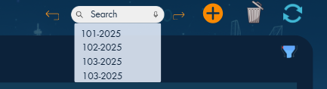
The given prototype is not fully inbuilt – as the option for viewing previous operations is not available .
And there is not option to delete any already created form .
Suggestion :
Or if u can give all the mentioned leftout together as a section on the top as view list/navigate to view all the operations in list showing the below headings
Date Type of operation Location Status Vsl name client barrels edit delete

When I click compatibility the drop down for forms and checklist is opening automatically .

For hose and fender calculation together in downloadable pdf option in office format is not available .

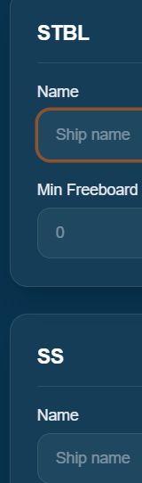

Its CHS & MS instead of STBL & SS

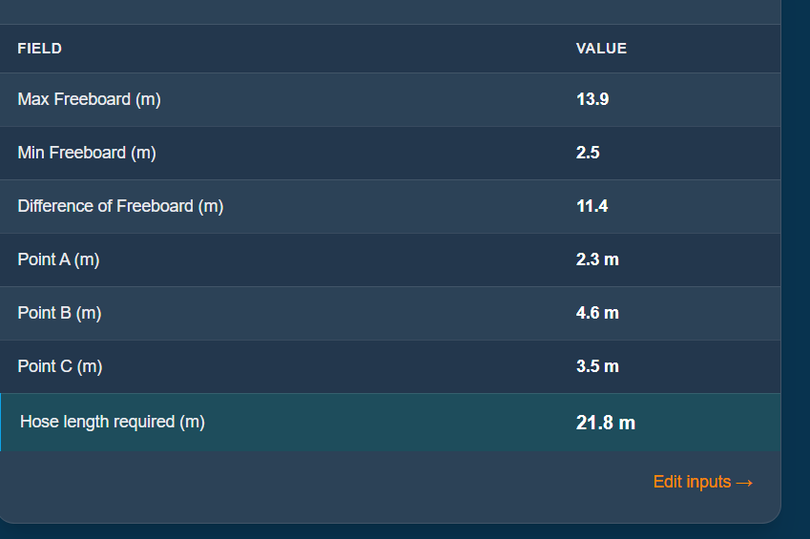
Values mismatch for Hose calculation in the overall length and point A -Please check
Ive used this 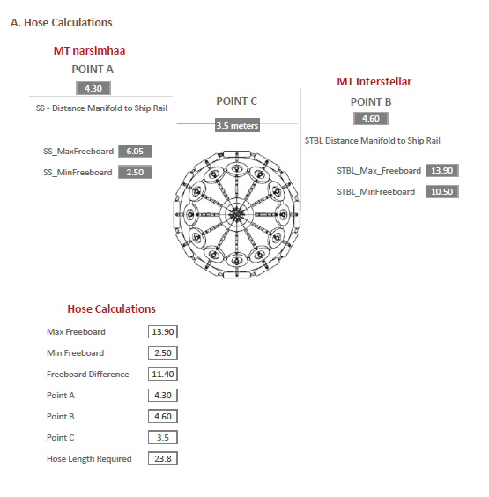

Same data mismatch for fender calculation too : 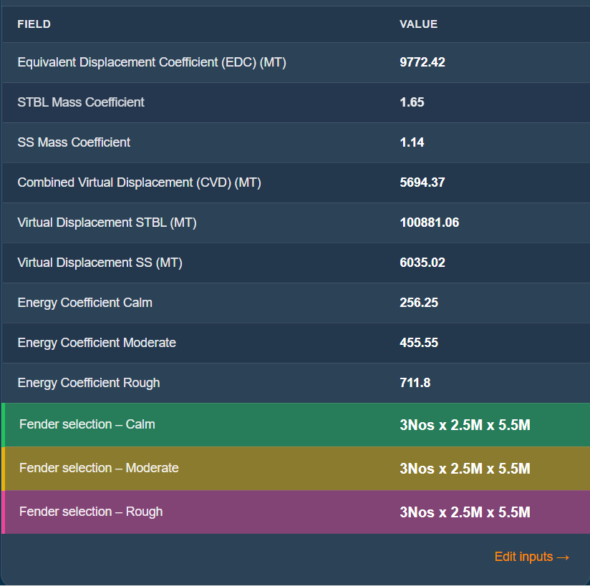
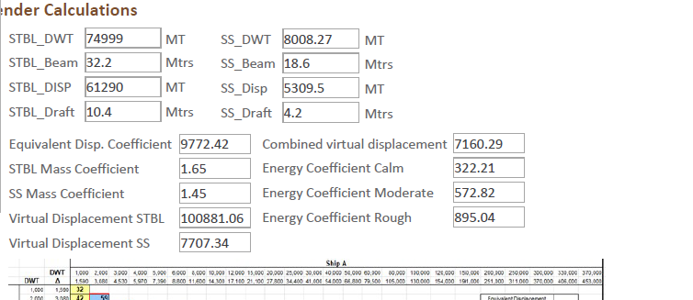

If I started to fill the datas and without clicking on calculate and just close the section just like that will the datas be autosaved ?

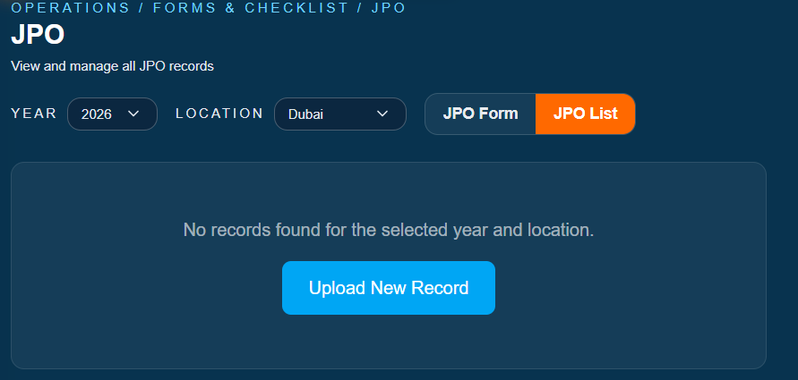
The locations in JPO is not fully updated


Change JPO form create form.

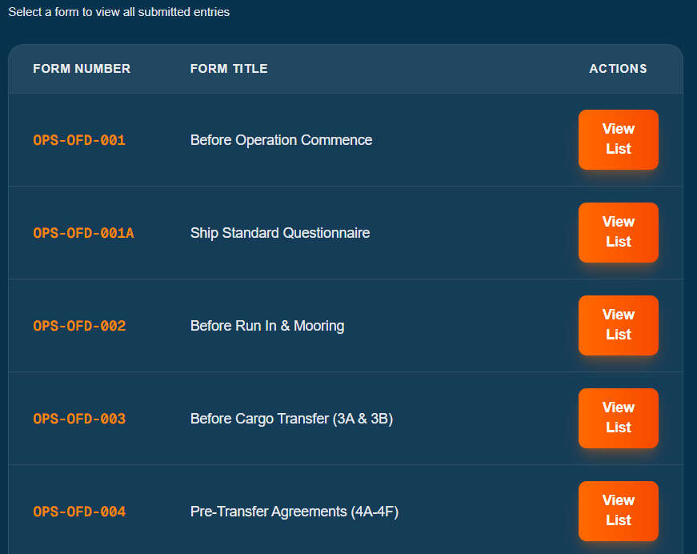

The STS checklist is not currently connected with the forms and advise if the forms will be viewed here and link can be taken from here to share with the third party .\
Quotation form is not the same as the word file .
None of the wording,para, agreement is present -Please advise.

And there were three quotation forms .
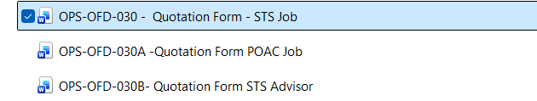
2 options:
- Make the form exactly like the both quotation word form in 6-8 pages each .(or )
- Give sections like
Type of document ( Check box)

STS job Quotation form
POAC quotation form
STS advisor Quotation Form

Date Proposed | From | To | Client Company name | Proposed by | Agreement accepted by .

& section to upload the word document

Downloadable option . save .

And list view to view the list of created items .

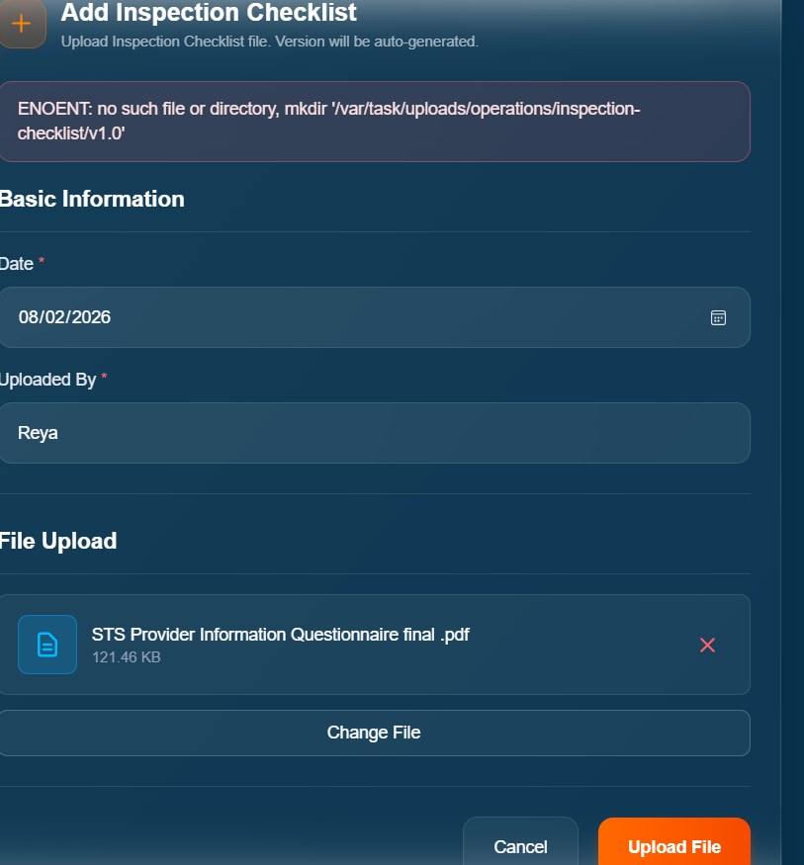
I could test by uploading document & There is no filter by location /year options .

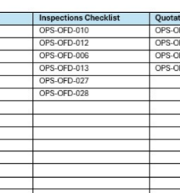For the Given inspection checklist around 6 – the path to file is not given .

Each are different checklist , under inspection section no sub division of different fiorm names are given ?

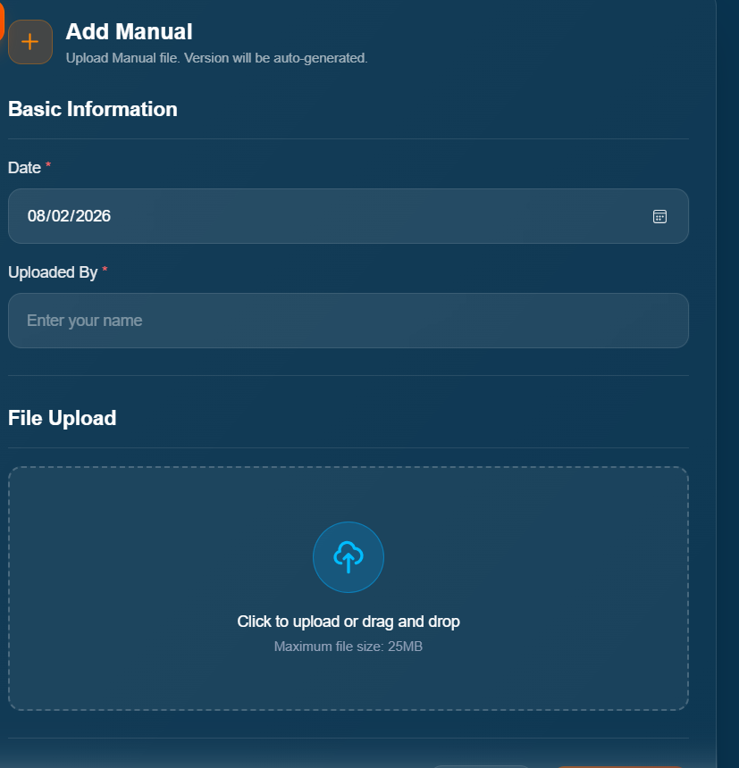
For manual add two section of Revision Number / revision date .

And in list filters are NA?

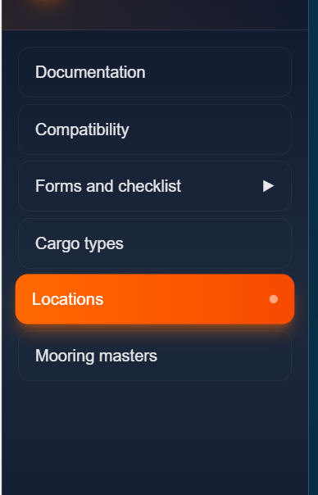
Cargo types /Manage Locations/ Mooring Master option – Make it visible only for admin not for everyone .

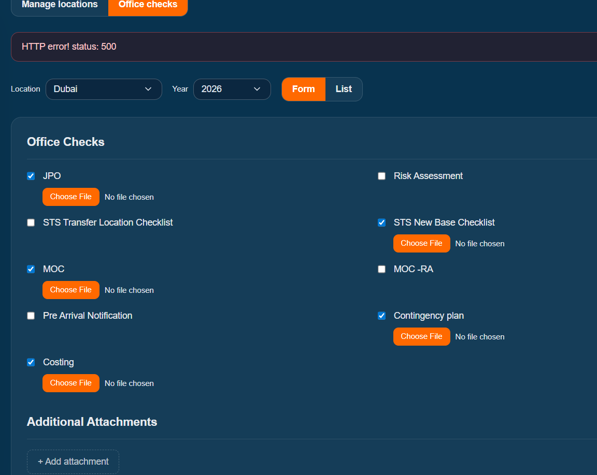
I couldn’t test ,it shows error while saving .

Regarding Forms in operations Dept .

- No header is the format of the word file the Rev date and the rev Numeber are not the same present .

And when I tested saving a form it is not viewed in Checklist form list .?
Also if I want to download the filed documents of forms , there is no option for that .

As far there is no downloadable option seen in the operations dept, ??

The STS checklist forms – should be identified by Job/operation Number to differentiate each

But there is no identification is there in the form to find out that form is filled for that particular operation number ?

